**Funding Success Analysis**

1. **Overview**: Purpose of this analysis.

The purpose of this analysis was to determine whether funding provided by Alphabet Soup to different applicants will result in the execution of a successful venture or not. What success means is not clearly defined, but it is indicated as a boolean variable. However, defining success differently (such as achieving certain valuation for their venture) might result in a higher quality model.

Furthermore, the income is provided as a range, while the asked amount is provided as a number. My opinion is that utilizing a number for income instead of a range would result in a higher quality model.

1. **Results**: Using bulleted lists and images to support your answers, address the following questions:

* Data Preprocessing
  + What variable(s) are the target(s) for your model?
    - Target:
      * IS_SUCCESSFUL
  + What variable(s) are the features for your model?
    - The features are:
      * APPLICATION_TYPE
      * AFFILIATION
      * CLASSIFICATION
      * USE_CASE
      * ORGANIZATION
      * STATUS
      * INCOME_AMT
      * SPECIAL_CONSIDERATIONS
      * ASK_AMT
  + What variable(s) should be removed from the input data because they are neither targets nor features?
    - Neither targets nor features:
      * EIN
      * NAME
* Compiling, Training, and Evaluating the Model
  + How many neurons, layers, and activation functions did you select for your neural network model, and why?
    - Neurons: 129; it’s the recommended amount of 2-3 times the amount of features (43).
    - Layers: 2 hidden layers + 1 output layer; started with 2, then did 3 without seeing significant improvement.
    - Activation functions:
      * Hidden layer 1: relu; it’s better to use more complex functions for hidden layers.
      * Hidden layer 2: relu
      * Output layer: tanh; tanh was slightly better than sigmoid.
  + Were you able to achieve the target model performance?
    - No, the accuracy stayed at around 74%. My guess is that the data isn’t of enough quality.
  + What steps did you take in your attempts to increase model performance?
    - I added 2 more layers
    - I added more neurons
    - I removed 2 columns (Classification and Application Type): This negatively affected accuracy but not for a lot, which means these features don’t explain a big part of the outcome.

**Old data:**

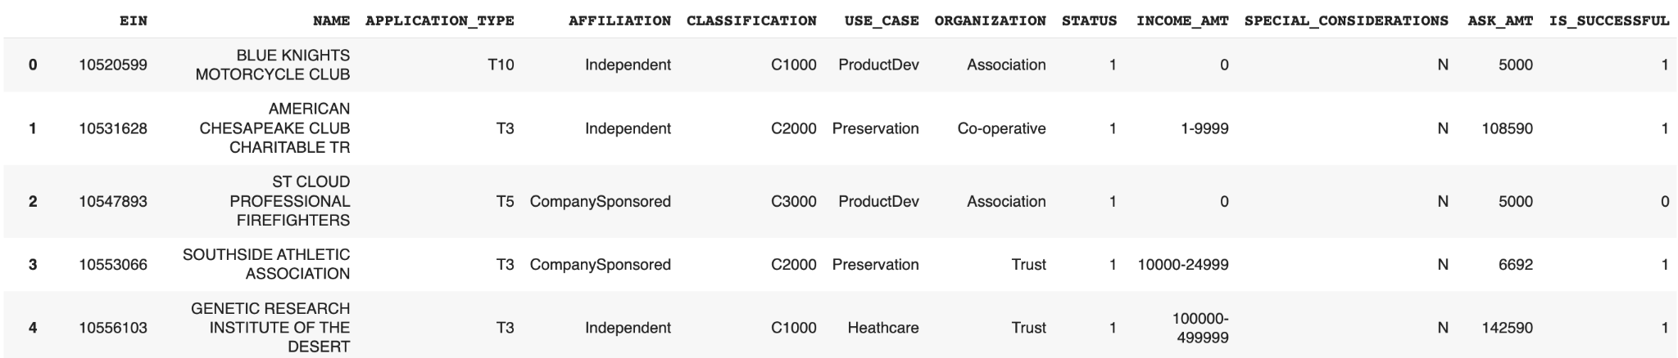

**Old model:**

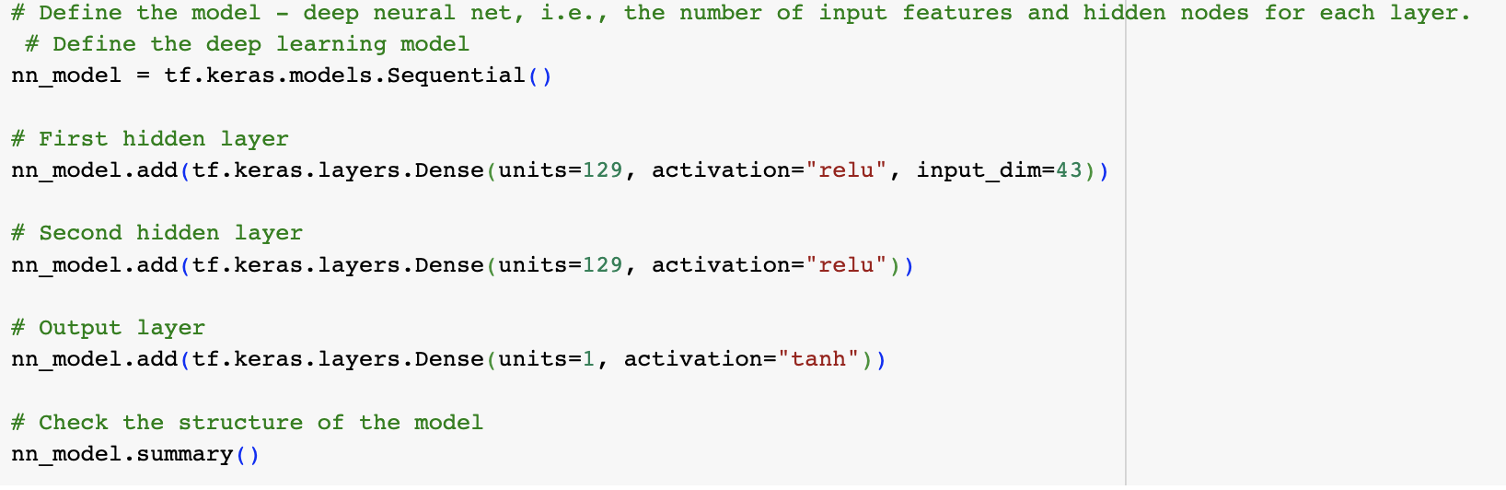

**New data:**

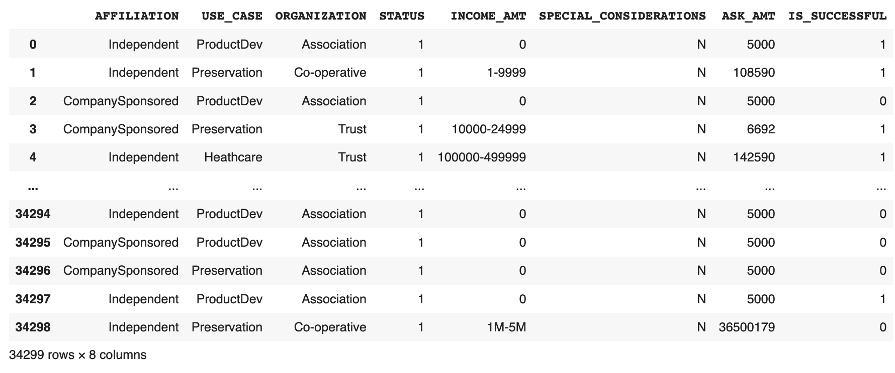

**New model:**

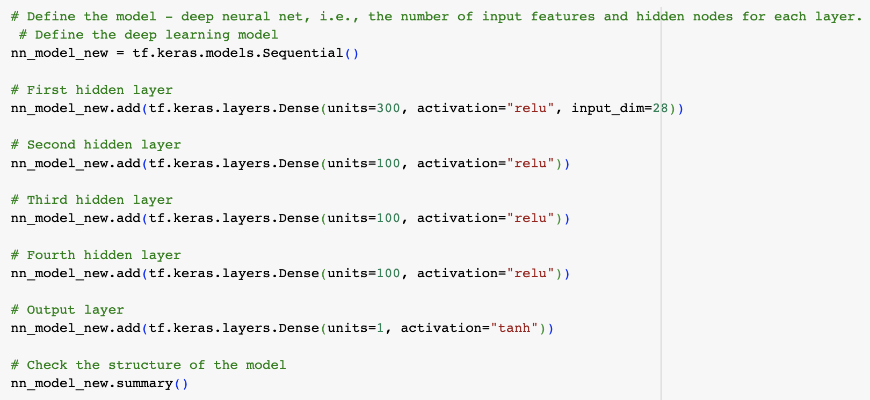

1. **Summary**: Summarize the overall results of the deep learning model. Include a recommendation for how a different model could solve this classification problem, and then explain your recommendation.

The deep learning model performed better with the Classification and Application Type features, although just slightly (73.71% vs 70.04% accuracy). However, these features are categories, and when encoded they result in a lot of added new features.

I believe this is a poor model because we have poor data with a lot of categorical features with a lot of possible values. My guess is that if we had numerical data instead, and had a more clear definition for success, our model would perform a lot better.

My recommendation would be to gather data in a different manner so that we can have numerical values instead of categorical values, which would lead to a model that is far more accurate.